# **IIS installation**

**Assumptions**

This article assumes you have an existing windows server.

Here are the steps to install IIS:

1. Login to the server and select server manager.

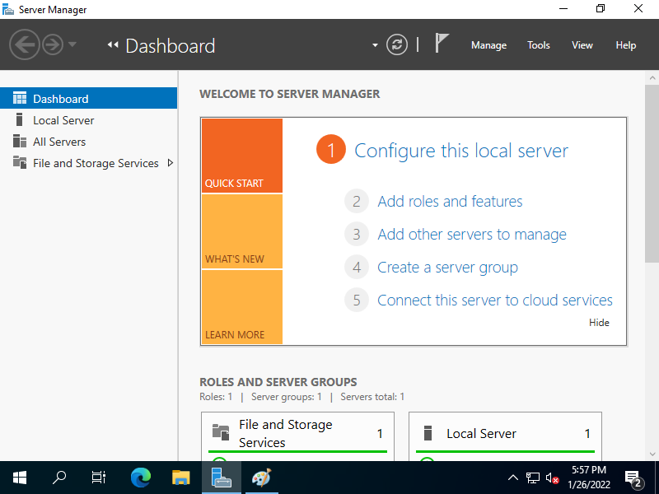

1. Select add roles and features and click next.

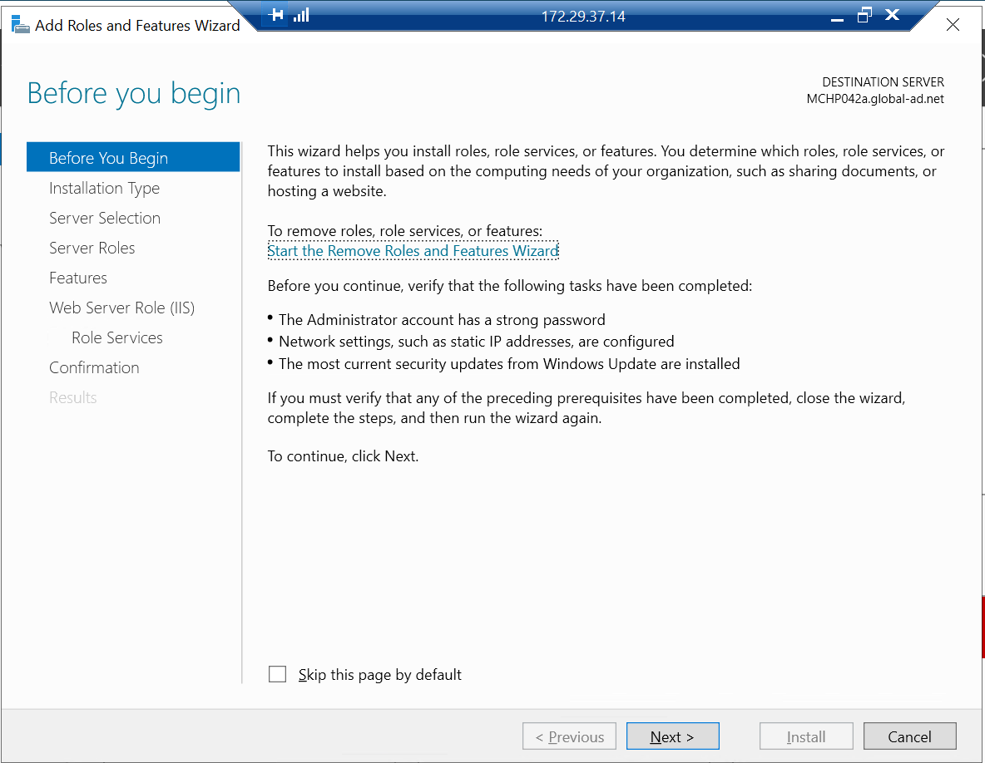

1. Select role-based or feature-based installation option for installation type.

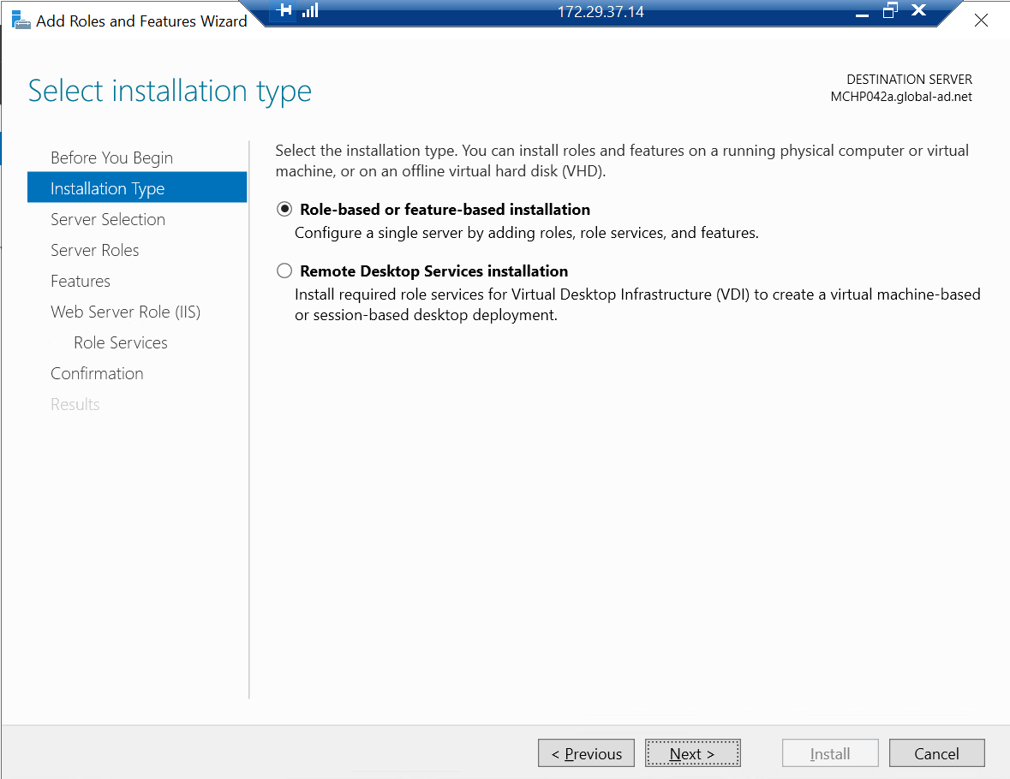

1. Select a server from the server pool option in destination server.

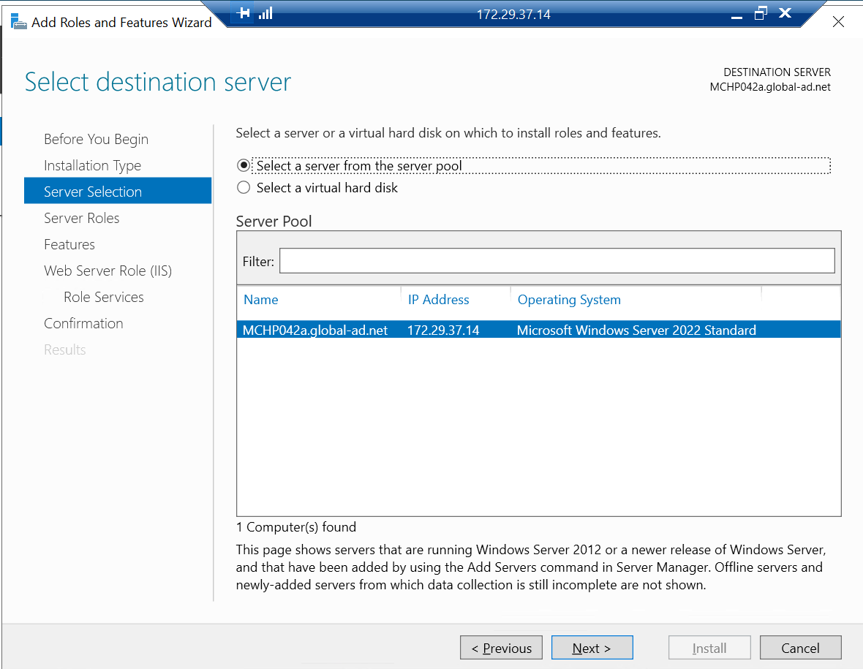

1. Select the required server roles.

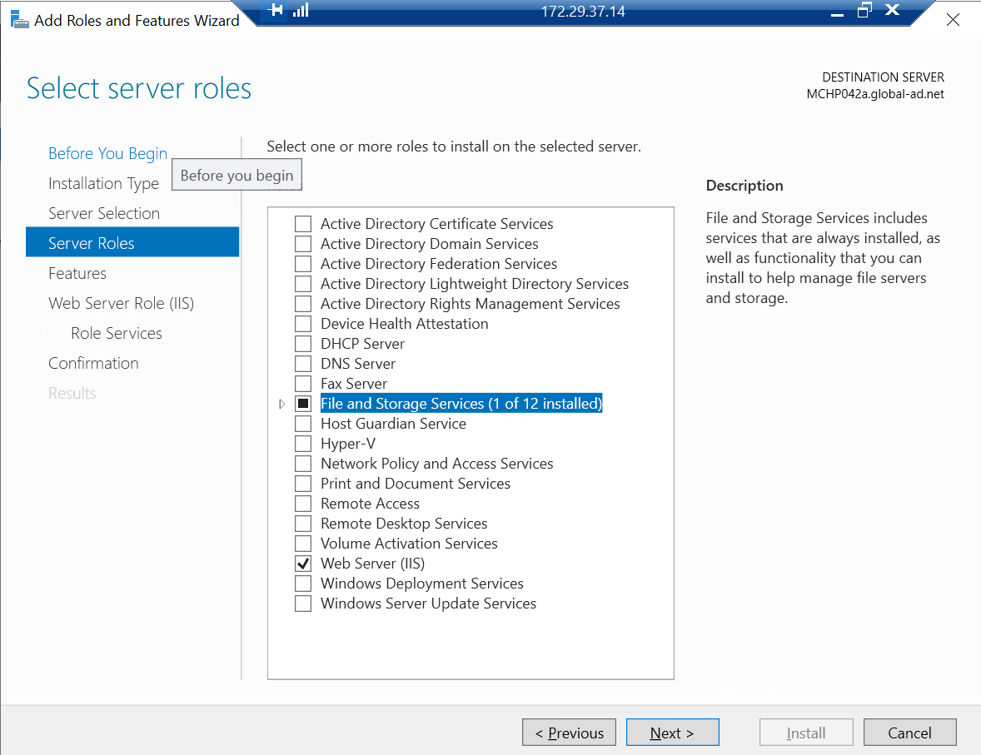

1. Select the features required for the services.

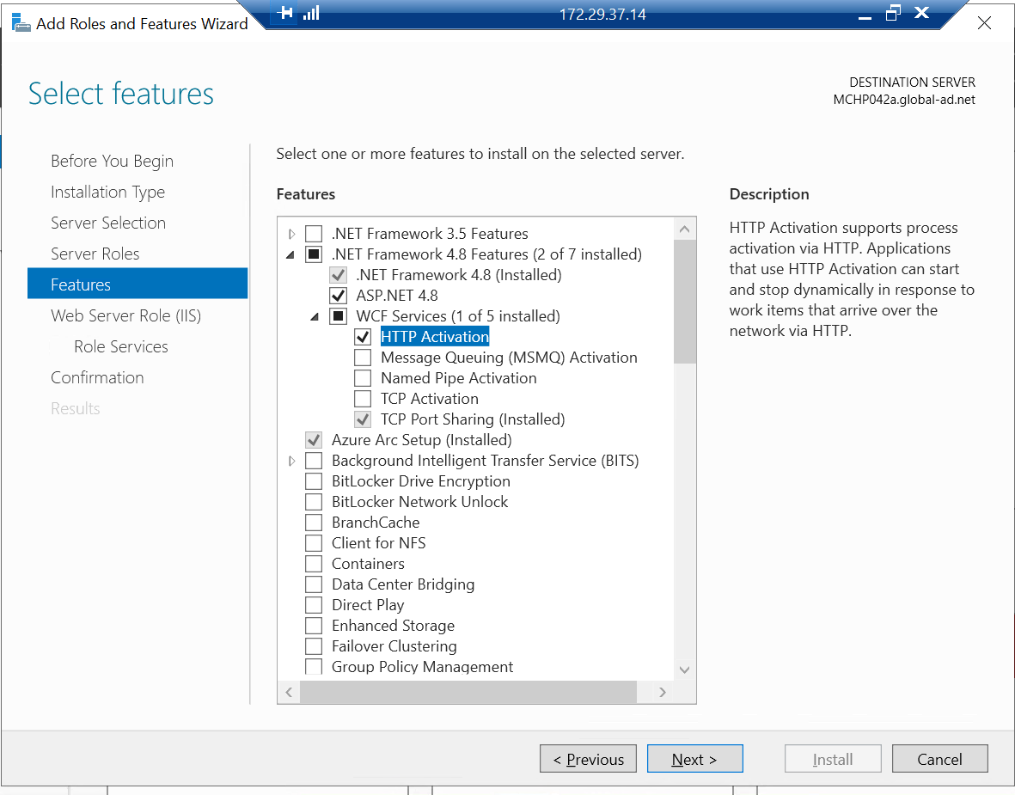

1. Click next.

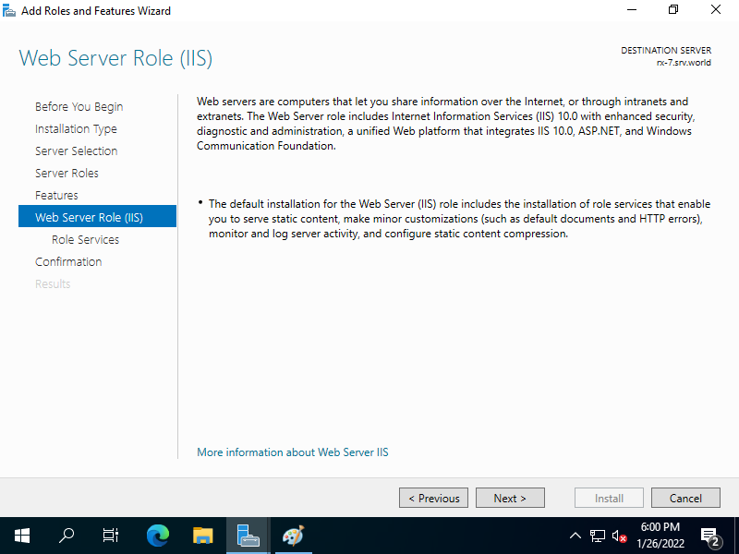

1. Select the role services required for the service.

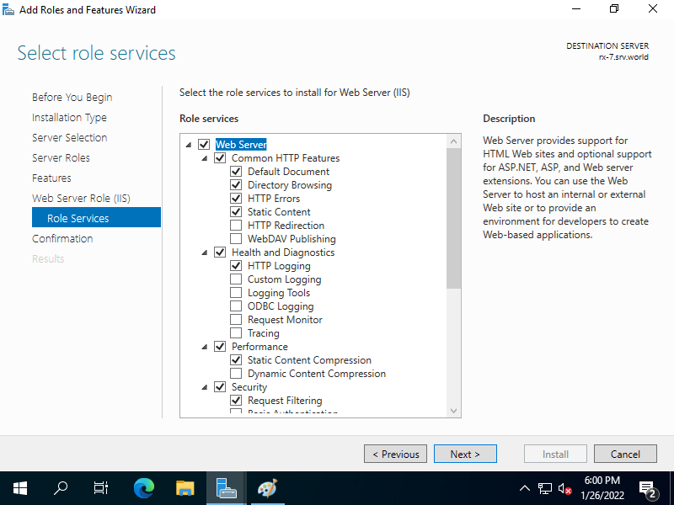

1. Check the selected roles and features.

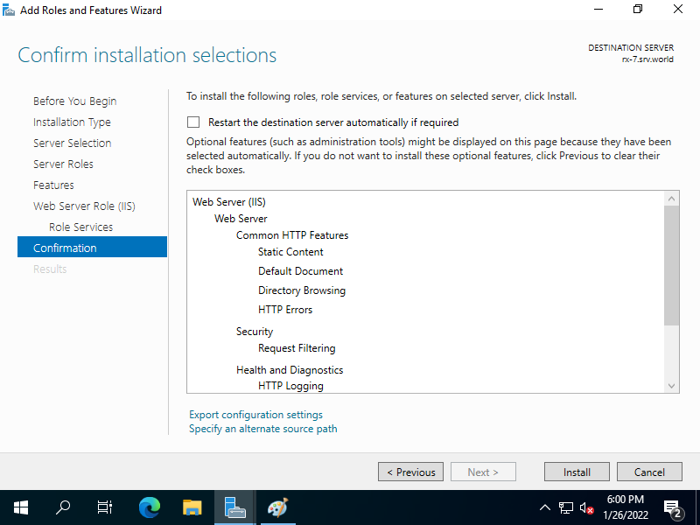

1. Wait for installation process.

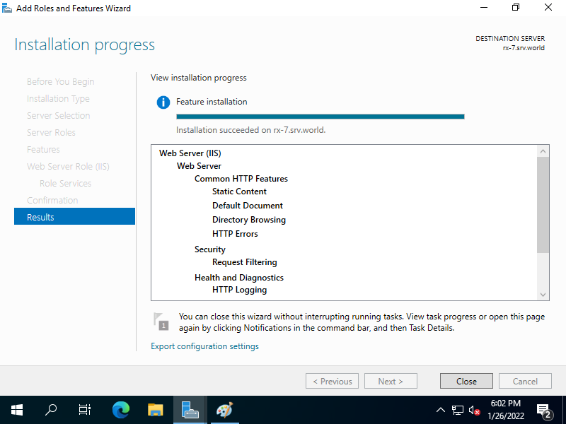

1. IIS installation completed.

